**ABSTRACT**

The Facial-Based Attendance Management System presents a modern solution to the challenges associated with traditional attendance tracking methods in organizational settings. Leveraging advanced facial recognition technology, FBAMS automates the attendance marking process, eliminating the need for manual sign-in procedures, and enhancing accuracy and efficiency.

Key features of FBAMS include user-friendly interfaces for both users and administrators, real-time data processing capabilities, and robust security measures to protect sensitive biometric and personal information. The system is designed to be scalable, flexible, and compliant with regulatory requirements, making it suitable for deployment in diverse organizational environments.

By streamlining attendance tracking processes and providing reliable, real-time data insights, FBAMS empowers organizations to optimize resource allocation, improve operational efficiency, and ensure compliance with attendance policies and regulations. Overall, FBAMS represents a significant advancement in attendance management technology, offering organizations a reliable, secure, and user-friendly solution to their attendance tracking needs.

**CHAPTER-1**

**INTRODUCTION**

* 1. **Overview**

The facial-based attendance management system presented in the project is a sophisticated solution designed to automate attendance tracking in a user-friendly and efficient manner. Leveraging facial recognition technology, the system accurately identifies individuals and marks their attendance seamlessly.

The system integrates with a web-based interface powered by Flask, offering a convenient platform for interaction. Users can easily register new individuals, view attendance records, and perform other administrative tasks with just a few clicks.

Moreover, the system prioritizes data protection, employing encryption and secure storage practices to shield personal information from unauthorized access or breaches.

An essential aspect of the system is its scalability and adaptability. It can seamlessly integrate into schools, colleges, startups and many more industries which takes attendance on the daily basis. Additionally, the system's modular design allows for easy customization to accommodate specific requirements or evolving operational workflows.

Overall, the facial-based attendance management system represents a powerful tool for streamlining attendance tracking processes in healthcare settings. By combining advanced facial recognition technology with user-friendly interfaces and robust security features, the system empowers hospitals and medical institutions to efficiently manage attendance while prioritizing data security and privacy.

* 1. **Problem Introduction.**

In many organizational settings, traditional methods of attendance tracking have been plagued by inefficiencies, inaccuracies, and susceptibility to manipulation. Manual processes involving paper-based sign-in sheets or electronic systems relying on ID cards or biometric scans are often cumbersome and prone to errors.

Recognizing these challenges, there arises a need for a more sophisticated and reliable solution. The facial-based attendance management system emerges as a modern and efficient alternative. By leveraging facial recognition technology, this system offers a streamlined approach to attendance tracking, free from the limitations of traditional methods.

The shortcomings of conventional attendance tracking methods underscore the importance of adopting a more advanced and secure approach. Whether in corporate environments, educational institutions, or other organizational settings, accurate attendance tracking is vital for operational efficiency, compliance, and security.

With the facial-based attendance management system, organizations can revolutionize their attendance tracking processes. This system provides a seamless and reliable way to verify individuals' identities, mark their attendance, and maintain accurate records without the need for physical tokens or manual inputs.

In the following sections, we will explore the implementation of the facial-based attendance management system, highlighting its key features, benefits, and the underlying technologies driving its effectiveness in diverse organizational contexts.

* 1. **Objectives**
* **Automate Attendance Tracking:** The primary goal of FBAMS is to automate the process of attendance tracking using facial recognition technology. This eliminates the need for manual methods such as paper-based sign-in sheets or ID card scanning, saving time, and reducing errors.
* **Enhance Accuracy:** FBAMS aims to improve the accuracy of attendance records by leveraging facial recognition algorithms to identify individuals. This helps prevent issues such as buddy punching or unauthorized access, ensuring that attendance data is reliable and trustworthy.
* **Increase Efficiency:** By streamlining the attendance tracking process, FBAMS enhances overall operational efficiency. Employees or students can quickly and easily mark their attendance simply by being present, without the need for additional steps or devices.
* **Improve Security:** The system enhances security by using biometric data (facial features) for attendance verification. This reduces the risk of identity fraud or unauthorized access, ensuring that only authorized individuals can record their attendance.
* **Improve Security:** The system enhances security by using biometric data (facial features) for attendance verification. This reduces the risk of identity fraud or unauthorized access, ensuring that only authorized individuals can record their attendance.
* **Provide Real-Time Data:** FBAMS provides real-time attendance data, allowing administrators or supervisors to access up-to-date information on attendance status. This facilitates better decision-making and resource allocation within the organization.
* **Offer User-Friendly Interface:** The system is designed to be user-friendly, with an intuitive interface that makes it easy for users to mark their attendance and for administrators to manage attendance records.
* **Ensure Compliance:** FBAMS helps ensure compliance with attendance policies and regulations by maintaining accurate and reliable attendance records. This can be particularly important in industries or organizations where attendance tracking is closely monitored or regulated.
* **Facilitate Reporting and Analysis:** The system enables administrators to generate attendance reports and perform analysis on attendance data. This can provide insights into attendance patterns, trends, and potential areas for improvement.
  1. **Scope of the project**

The Facial-Based Attendance Management System offers a comprehensive solution for automating attendance tracking through the utilization of facial recognition technology. At its core, FBAMS streamlines the attendance process by enabling individuals to mark their presence with a simple facial scan, eliminating the need for traditional manual methods like sign-in sheets or biometric devices. By leveraging advanced facial recognition algorithms, the system accurately identifies users based on their unique facial features, ensuring reliable attendance verification. FBAMS encompasses various functionalities, including user authentication, database management, and real-time data processing. It provides a user-friendly web interface for individuals to mark attendance and for administrators to manage attendance records efficiently. Security and privacy are paramount, with FBAMS implementing robust measures such as encryption and access controls to safeguard sensitive data. Additionally, the system is designed to be scalable and adaptable, capable of integrating with existing organizational systems and accommodating diverse attendance policies and regulatory requirements. In essence, FBAMS offers organizations a sophisticated yet user-friendly solution to enhance accuracy, efficiency, and security in attendance management.

* 1. **Modules:**

The entire project mainly consists of 8 modules, they are:

1. Facial Recognition Module
2. Database Management Module
3. Web Interface Module
4. Real-Time Processing Module
5. Security and Privacy Module
6. Reporting and Analytics Module
7. Scalability and Flexibility Module
8. Compliance Module
   * 1. **Facial Recognition Module:**

* This module is the core of FBAMS and is responsible for performing facial recognition tasks.
* It includes algorithms for detecting faces in images or video streams and comparing them against stored facial templates to identify individuals.
  + 1. **Database Management Module:**
* This module manages the storage and retrieval of data related to users, attendance records, and other system information.
* It includes functions for inserting, updating, deleting, and querying data from the database.
  + 1. **Web Interface Module:**
* The Web Interface module provides a user-friendly interface for interacting with FBAMS.
* It includes web pages or APIs for users to mark their attendance, view attendance records, and perform administrative tasks.
  + 1. **Real-Time Processing Module:**
* This module handles real-time processing of attendance data.
* It processes attendance information as it is captured, allowing for immediate updates to attendance records and status.
  + 1. **Security and Privacy Module:**
* The Security and Privacy module ensures the protection of sensitive data within FBAMS.
* It includes mechanisms for encrypting data, implementing access controls, and maintaining compliance with privacy regulations.
  + 1. **Reporting and Analytics Module:**
* This module generates reports and provides analytical insights based on attendance data.
* It allows administrators to track attendance trends, identify patterns, and make informed decisions.
  + 1. **Scalability and Flexibility Module:**
* The Scalability and Flexibility module ensures that FBAMS can adapt to the needs of different organizations and environments.
* It includes features for scaling the system to accommodate varying numbers of users and attendance policies.
  + 1. **Compliance Module:**
* The Compliance module ensures that FBAMS complies with relevant regulations and standards governing attendance tracking and data protection.
* It includes auditing, logging, and reporting functionalities to demonstrate compliance.

These modules work together seamlessly to provide a comprehensive solution for facial-based attendance management, enhancing accuracy, efficiency, and security within organizations.

**CHAPTER-2**

**LITERATURE SURVEY**

A literature survey on Facial-Based Attendance Management Systems (FBAMS) can encompass various aspects related to facial recognition technology, attendance management, and their applications in organizational settings. Here are some points to consider:

* 1. **Literature Survey**
     1. **Overview of Facial Recognition Technology:**
* Review the fundamentals of facial recognition technology, including its principles, algorithms, and advancements in recent years.
* Explore different approaches to facial recognition, such as feature-based, template-based, and deep learning-based methods.
  + 1. **Existing Attendance Management Systems:**
* Survey existing attendance management systems and technologies, including traditional methods and modern solutions like biometric systems and RFID-based systems.
* Identify strengths, weaknesses, and limitations of these systems in terms of accuracy, efficiency, and user experience.
  + 1. **Applications of Facial Recognition in Attendance Management:**
* Examine the use of facial recognition technology in attendance management systems across various industries and organizational settings.
* Discuss case studies or real-world examples of organizations implementing FBAMS and the outcomes they have achieved.
  + 1. **Challenges and Limitations:**
* Investigate the challenges and limitations associated with FBAMS, such as privacy concerns, accuracy issues, and ethical considerations.
* Analyse factors that may impact the effectiveness of facial recognition technology in attendance management, such as environmental conditions and variability in facial features.
  + 1. **Security and Privacy Considerations:**
* Discuss security measures and privacy safeguards implemented in FBAMS to protect sensitive biometric data and personal information.
* Review regulatory frameworks and compliance requirements relevant to facial recognition technology and attendance management systems.
  + 1. **User Acceptance and Adoption:**
* Explore factors influencing user acceptance and adoption of FBAMS, including usability, perceived usefulness, and concerns about privacy and data security.
* Investigate strategies for promoting user acceptance and overcoming resistance to change during the implementation of FBAMS.
  + 1. **Future Trends and Emerging Technologies:**
* Identify emerging trends and advancements in facial recognition technology and attendance management systems, such as multi-modal biometrics, edge computing, and artificial intelligence.
* Discuss potential future developments and their implications for the evolution of FBAMS in organizational settings.
  + 1. **Comparative Analysis and Benchmarking:**
* Conduct a comparative analysis of FBAMS with other attendance management systems, evaluating factors such as accuracy, efficiency, scalability, and cost-effectiveness.
* Benchmark FBAMS against industry standards and best practices to assess its performance and effectiveness.
  + 1. **User Feedback and Case Studies:**
* Gather user feedback and insights from organizations that have implemented FBAMS, including their experiences, challenges faced, and lessons learned.
* Present case studies or success stories showcasing the benefits and outcomes achieved through the adoption of FBAMS in real-world scenarios.
  + 1. **Research Gaps and Future Directions:**
* Identify research gaps and areas for future exploration in the field of FBAMS, such as improving accuracy in challenging conditions, enhancing user experience, and addressing privacy concerns.
* Propose research directions and methodologies for addressing these gaps and advancing the state-of-the-art in FBAMS.
  1. **EXISTING SYSTEM**

The existing system refers to the methods and technologies currently in use for attendance management before the implementation of the Facial-Based Attendance Management System (FBAMS). Here are some points to consider when discussing the existing system:

* Manual Attendance Tracking
* Biometric Attendance Systems
* RFID-Based Systems
  1. **Challenges with Existing Systems:**
* Manual attendance tracking systems can be time-consuming, prone to errors, and susceptible to manipulation (e.g., buddy punching).
* Biometric systems may face challenges related to hygiene concerns (e.g., fingerprint scanners) or technical issues (e.g., difficulty in recognizing certain biometric traits).
* RFID-based systems may require individuals to carry or wear RFID cards or tags, which can be lost or forgotten.
* Existing systems may lack real-time data processing capabilities, making it difficult for administrators to access up-to-date attendance information.
* The user experience with existing systems can vary, with some systems being more user-friendly and intuitive than others.
* Issues such as long queues at biometric terminals or difficulties in locating and using RFID scanners may affect user satisfaction.
* Organizations using existing attendance management systems must ensure compliance with relevant regulations and privacy laws governing the collection, storage, and use of attendance data.
  1. **Proposed System**

The proposed system, Facial-Based Attendance Management System (FBAMS), presents a modern and technologically advanced solution to address the shortcomings of traditional attendance management methods. Here are the key components and features of the proposed system:

* Real-Time Attendance Tracking
* Facial Recognition Technology
* Scalability and Integration
* Compliance and Data Protection
* Continuous Improvement and Updates
  1. **FEASIBILITY STUDY**

The feasibility study assesses the viability and practicality of implementing the Facial-Based Attendance Management System (FBAMS) within an organization. It evaluates various aspects such as technical feasibility, economic feasibility, and operational feasibility to determine whether the proposed system is feasible and beneficial. Here's a breakdown of each aspect:

* + 1. **Technical Feasibility:**
* Technical feasibility examines whether the proposed FBAMS can be developed using existing technology and resources.
* It assesses factors such as the availability of facial recognition technology, compatibility with existing IT infrastructure, and the expertise of the development team.
* The study considers potential technical challenges and determines whether they can be overcome within reasonable constraints.
  + 1. **Economic Feasibility:**
* Economic feasibility evaluates the cost-effectiveness of implementing FBAMS compared to the benefits it offers.
* It includes a cost-benefit analysis to estimate the initial investment required for system development, hardware/software procurement, implementation costs, and ongoing operational expenses.
* The study also considers the potential return on investment (ROI) derived from improved efficiency, reduced administrative overhead, and other tangible and intangible benefits.
  + 1. **Operational Feasibility:**
* Operational feasibility assesses whether the proposed FBAMS aligns with the organization's operational requirements and objectives.
* It considers factors such as user acceptance, ease of use, integration with existing business processes, and potential disruption to operations during implementation.
* The study evaluates stakeholders' readiness for change, training needs, and the level of organizational support required for successful implementation.

**CHAPTER-3**

**REQUIREMENT SPECIFICSTION**

* 1. **Functional Requirements:**

Functional requirements specify what the Facial-Based Attendance Management System (FBAMS) must do to satisfy the users’ needs and achieve its intended objectives. These requirements are crucial for developers, guiding the design and development process to ensure the system meets all expected functionalities. Here’s a detailed list of functional requirements for the FBAMS:

* User Registration and Management
* Facial Recognition for Attendance
* Attendance record Management
* Real-time Attendance Monitoring
* User Interface and Experience
* Backup and Recovery
  1. **Non-Functional Requirements**

Non-functional requirements (NFRs) are just as crucial as functional requirements because they describe how the system operates rather than what it does. For the Facial-Based Attendance Management System (FBAMS), these requirements ensure the system’s reliability, usability, and efficiency. Here are the key non-functional requirements for the FBAMS:

* Performance
* Security
* Reliability and Availability
* Scalability
* Maintainability
* Compliance
* Usability
  1. **Hardware Requirements**
* CPU: Intel Core
* Cores: Single (Dual /Quad Core is recommended)
* RAM: 4 GB (6 GB recommended)
* Graphic Accelerators: 15 VGA color.
* Display Resolution: 1280*1024 is recommended, 1024*768 is minimum.
* Webcam: 720 minimum required.
  1. **Software Requirements**
* Front END: HTML, FLASK
* Backend: Python, MySQL
* Database: MySQL Community Server
* Browser: any of your choice
* Server: Flask
* OS Supported: win7 to any latest.
  1. **Software Description**
     1. **Visual Studio 2022**

Visual Studio Code is a free coding editor that helps you start coding quickly. Use it to code in any programming language, without switching editors. Visual Studio Code has support for many languages, including Python, Java, C++, JavaScript, and more.

* + 1. **Fast and Smart Code Editing**

The visual studio code indents lines, matches words and brackets, and highlights source code syntactically and semantically. It lets you easily refractor code, with a range of handy and powerful tools, while it also provides code templates, coding tips, and code generators.

* + 1. **MySQL**
* **Introduction**

MySQL is a Relational Database Management System (RDBMS).

RDBMS means R—DB—MS,

R stands for Relational.

DB stands for Database, a repository for the information store.

The data in a database is organized into tables, and each table is organized into rows and columns. Each row in a table is called a record. A record may contain several pieces (called fields) of information, and cache column in a table is known as a field.

MS stands for Management System, the software that allows you to insert, retrieve, modify, or delete records,

R stands for Relational, indicates a particular kind of DBMS that is good at relating information stored in one table to information stored in another table by looking for elements common to each of them. Relational DBMS has the advantage of efficient storage, and retrieval mechanisms for data, and uses normalization process during design of RDBMS.

* + 1. **Features of MySQL**
* Speed
* Ease of use
* Cost
* Query language Support.
* Connectivity and security
* Portability

**CHAPTER-4**

**SYSTEM DESIGN**

The system design of the Facial-Based Attendance Management System (FBAMS) encompasses several key components and architectural decisions. This design aims to ensure that the system is robust, scalable, and capable of handling real-world usage scenarios efficiently. Here’s an overview of the system design, focusing on its architecture, database design, user interface design, and security considerations.

* 1. **System Architecture**

The FBAMS can adopt a three-tier architecture, consisting of the presentation layer, the business logic layer, and the data access layer. This separation of concerns ensures modularity, scalability, and ease of maintenance.

* + 1. **Presentation Layer**

This is the front-end of the system, through which users interact. It should be designed for ease of use, with a clean and intuitive user interface. It can be web-based for accessibility across devices and platforms or a dedicated application for specific devices used in attendance management.

* + 1. **Business Logic Layer**

This layer processes the facial recognition data, attendance logic, and other core functionalities. It includes algorithms for facial detection and recognition, attendance processing, and reporting. This layer acts as a bridge between the presentation layer and the data access layer, ensuring the business rules and processes are correctly implemented.

* + 1. **Data Access Layer**

This layer is responsible for interactions with the database. It handles all data persistence mechanisms, including data storage, retrieval, update, and deletion. This layer ensures data integrity and security.

* 1. **Database Design**

The database should be designed to efficiently store and manage user data, attendance records, facial recognition data, and other relevant information. Key entities might include:

* Facial Data
* Attendance Records
* Real-time Markings
* Day-to-day updates
* User ID and more.
  1. **User Interface Design**

The user interface should be intuitive and easy to navigate. It should cater to various user roles, such as administrators to take care of the DB and validate, and to mark the attendance. Providing them with the necessary functionalities tailored to their needs. Considerations include:

* **Responsive Design:** Ensures the system is usable across a variety of devices, including smartphones, tablets, and desktop computers.
* **Accessibility:** It is designed with accessibility in mind to accommodate users with disabilities.
  1. **Integration Capabilities**

This system is designed in such a way that it can be easily integrated with the companies or places where attendance is still taken using the old methods at a very low cost and maintenance. This is also made ready to use as if someone is ready to adapt with the FBAMS he/she can easily workout through the User interface provided in the application.

**CHAPTER-5**

**DATABASE DESIGN**

* 1. **Schema Diagram**

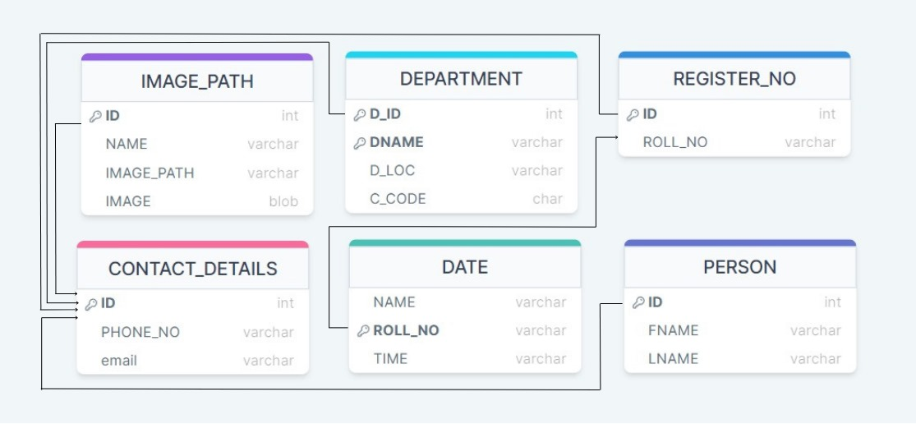

* 1. **ER Diagram**

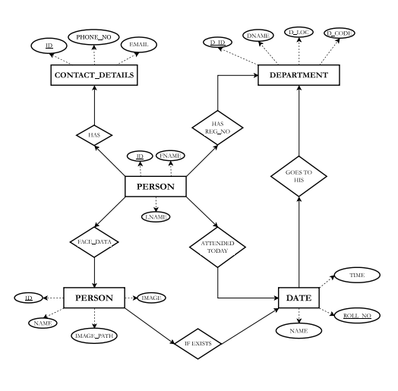

* 1. **Input Design**

Input design is part of overall system design that requires special attention designing input data is to make the data entered easy and free from errors. The input forms are designed using the controls available in Flask framework.

Input design is the process of converting the user originated inputs to a computer-based format. A system user interacting through a workstation must be able to tell the system whether to accept the input to produce reports. The collection of input data is considered to be most expensive part of the system design. Since the input has to be planned in such a manner so as to get relevant information, extreme care is taken to obtain pertinent information.

This project first will take the input using forms then it will be creating a contact details table which will help us to calculate daily attendance of the person.

* 1. **Output Design**

Output design this application “Facial Based Attendance Management System” generally refers to the results and information that are generated by the system for many end-users; output is the main reason for developing the system and the basis on which they evaluate the usefulness of the application.

The output is designed in such a way that it is attractive, convenient, and informative. Forms are designed with various features, which make the console output more pleasing.

As the outputs are the most important sources of information to the users, better design should improve the system’s relationships with us and will help in decision making. Form design elaborates the way output is presented and the layout available for capturing information.

One of the most important factors of the system is the output it produces; this system refers to the results and information generated. Basically, the output from a computer system is used to communicate the result of processing to the user,

Attendance management system to show the report subject wise attendance maintaining by staffs. Taken as a whole report obtains on a administrator privileges only.

**CHAPTER-6**

**DATABASE TABLE**

* 1. **Tables present in the Data Base.**

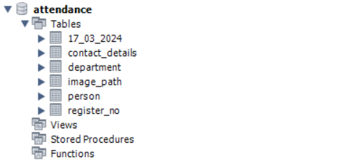

* 1. **Contact Details table.**

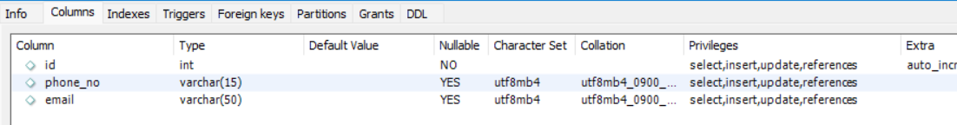

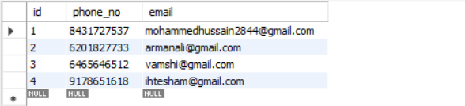

* 1. **Image_path table.**

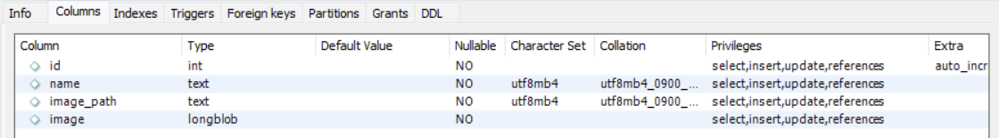

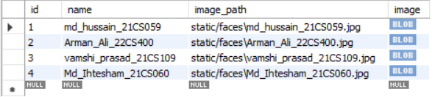

* 1. **Person table**

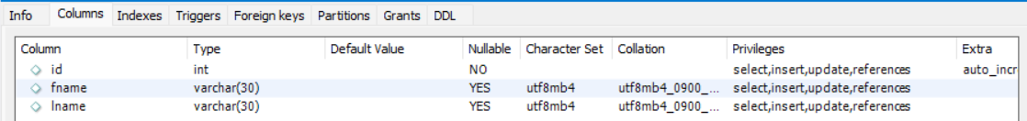

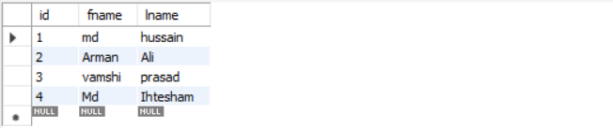

* 1. **Register_no table.**



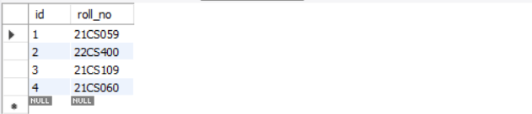

* 1. **Department Table.**

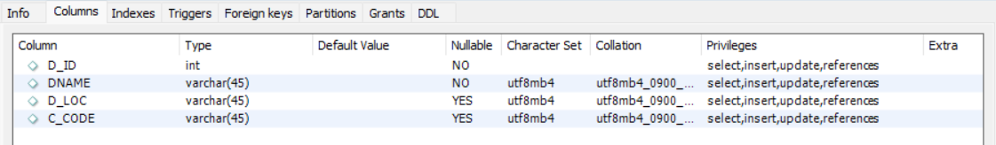

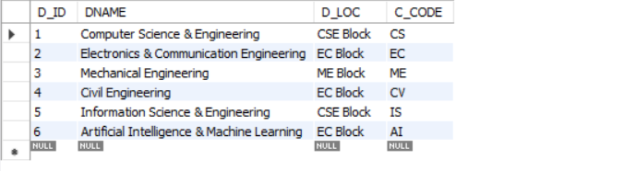

* 1. **Daily date named table.**

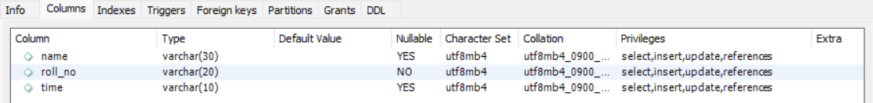

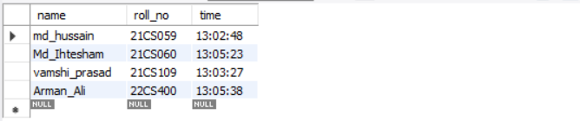

**CHAPTER-7**

**SYSTEM TESTING**

* 1. **Introduction**

Once source code has been generated, software must be tested to uncover (and correct) as many errors as possible before delivery to customer. Our goal is to design a series of test cases that have a high likelihood of finding errors. To uncover the errors software techniques are used. These techniques provide systematic guidance for designing test that Exercise the internal logic of software components, and exercise the input and output domains of the program to uncover errors in program function, behaviour and performance,

**Internal program logic is exercised using** —White box test case design Techniques.

**Software requirements are exercised using** —block box test case Design techniques.

In both cases, the intent is to find the maximum number of errors with the Minimum amount of effort and time.

* 1. **Testing Methodologies**

A strategy for software testing must accommodate low-level tests that are necessary to verify that a small source code segment has been correctly implemented as well as high-level tests that validate major system functions against customer requirements, A strategy must provide guidance for the practitioner and a set of milestones for the manager. Because the steps of the test strategy occur al a time when deadline pressure begins to rise, progress must be measurable, and problems must surface as early as possible. Following testing techniques are well known and the same strategy is adopted during this project testing.

* 1. **Unit testing**

Unit testing focuses verification effort on the smallest unit of software design- the software component or module, The unit test is white-box oriented, the unit testing implemented in every module of student attendance management System. By giving correct manual input to the system, the data are stored in database and retrieved. If you want required module to access input or gets the output from the End user. Any error will accrue the time will provide handler to show what type of error will be accrued.

* 1. **System testing**

System testing is actually a series of different tests whose primary purpose is to fully exercise the computer-based system, below we have described the two types of testing which have been taken for this project. It is to check all modules worked on input basis. If you want to change any values or inputs will change all information. So specified input is must.

* 1. **Performance Testing**

Performance testing is designed to test the run-lime performance of software within the context of an integrated system. Performance testing occurs throughout all steps in the testing process. Even at the unit level, the performance of an individual module may be assessed as white-box tests are conducted, this project reduces attendance table, codes. It will generate report fast.no have extra time or waiting of results. Entered correct data will show result few milliseconds, just used only low memory of our system, automatically do not getting access at another software. Get user permission and access to other applications.

**CHAPTER-8**

**SNAPSHOTS**

**Base Page: -**

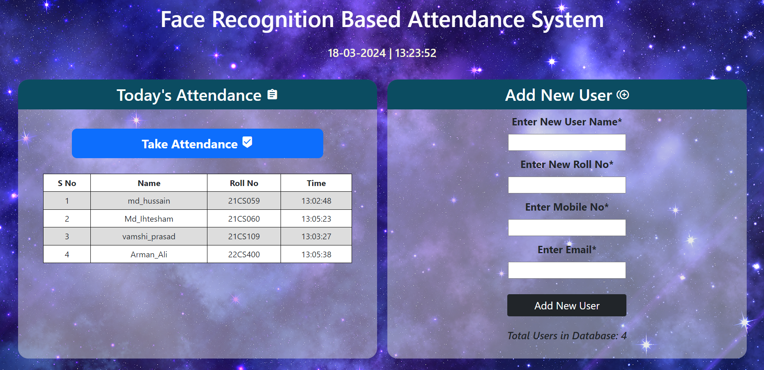

**New employee or student details form: -**

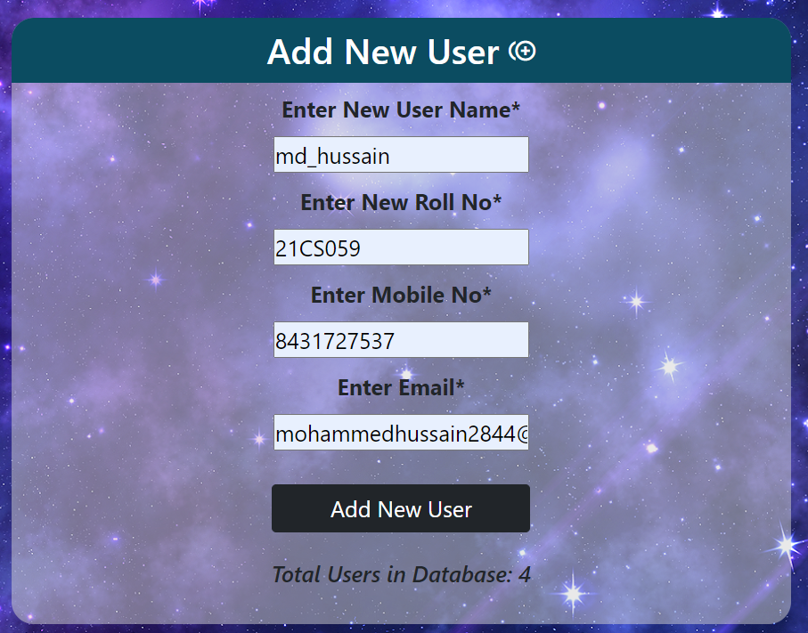

**Registers new user face: -**

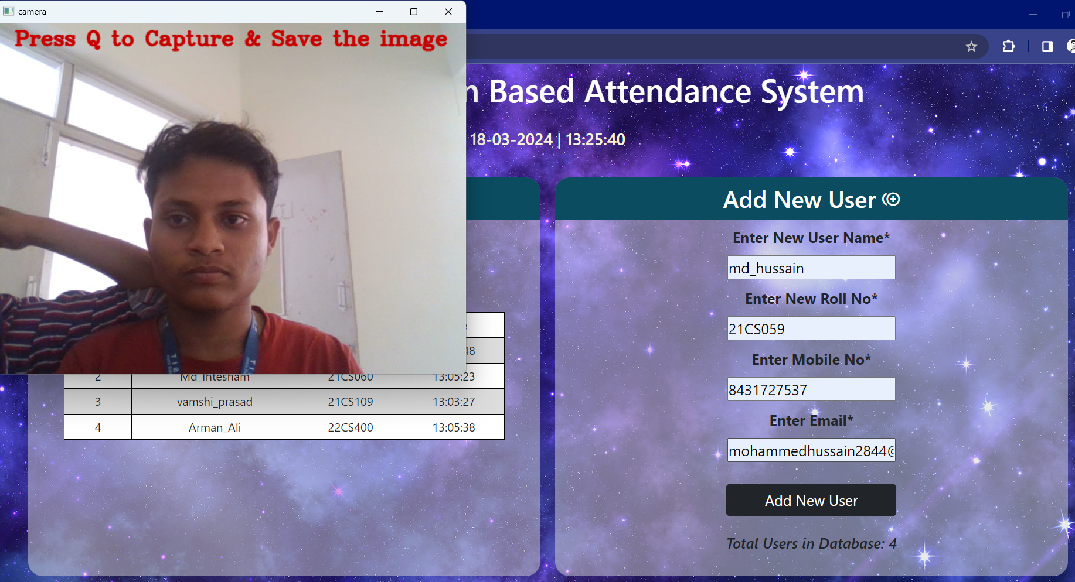

**List of people attended on the same day with accurate time: -**

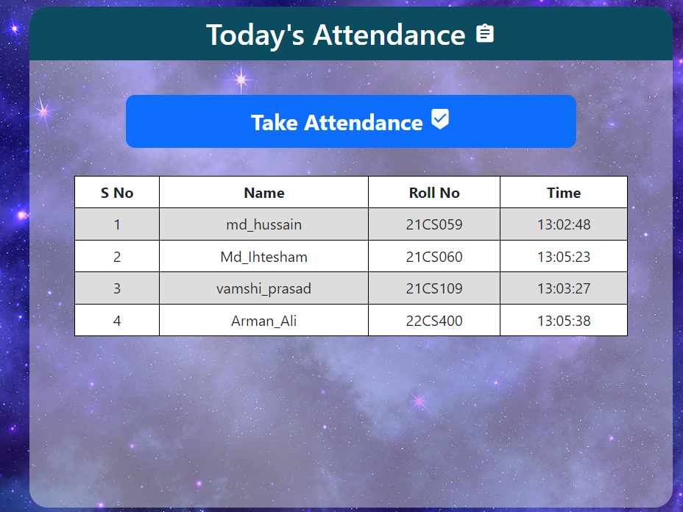

**Taking attendance using face: -**

Auto recognises the face and marks the attendance.

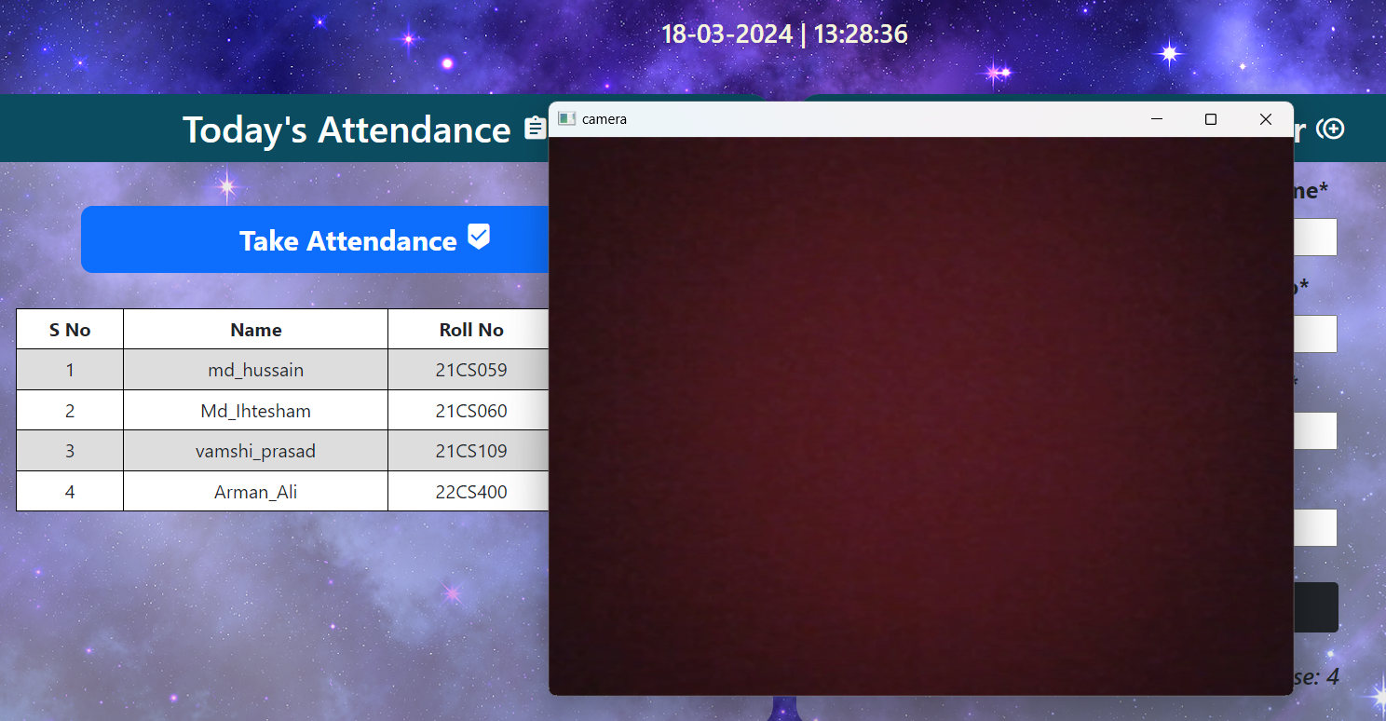

**CONCLUSION**

The Attendance Management System is developed using Visual Basic python fully meets the objectives of the system which it has been developed. The system has reached a steady state where all bugs have been eliminated. The system is operated at a high level of efficiency and all the teachers and user associated with the system understands its advantage. The system solves the problem. It was intended to solve as requirement specification,

**Scope for future development: -**

The project has a very vast scope in future. The project can be implemented on intranet in future. Project can be updated in near future as and when requirement for the same arises, as it is very flexible in terms of expansion, With the proposed software of database Space Manager ready and fully functional the client is now able to manage and hence run the entire work in a much better, accurate and error free manner.

**REFERENCES**

* Declaration ---https:/'www.slideshare.net
* Introduction to visual studio Microsoft.com Wikipedia.com
* Introduction to MySQL https://www.tutorialsweb.com
* homepage Design https://meenacademy.com!
* pictures/images Google Image Search
* Sql Database WampServer
* Some contents of YouTube.
* Behrouz A Forouzan, Data and Communications and Networking, Fifth Edition, McGraw Hill, Indian Edition
* Larry L Peterson and Brusce S Davie, Computer Networks, fifth edition, ELSEVIER
* Python references from [www.python.org](http://www.python.org)
* Flask: <https://flask.palletsprojects.com/en/3.0.x/>
* <https://www.w3schools.com/html/>
* https://www.w3schools.com/css/